**PRELIMINARY PROJECT PROPOSAL**

**Subject: ESE\_4009**

**Embedded System Design project**

**SMART CALENDAR**

**Instructor: Takis Zourntos**

|  |  |  |  |  |
| --- | --- | --- | --- | --- |
| Student Name | Navneet Kaur | Paras Dhand | Tanya Puri | Sanchana |
| Student ID | C0760074 | C0758260 | C0759737 | C0765521 |
| Signature | Nk | PD | TP | S |

`

**TITLE: SMART CALENDAR**

**INTRODUCTION OF THE SYSTEM**:

In recent times, technology has become an unavoidable part of our everyday life. With the rapid advancement in technology, people are expected to be high-yielding and efficient in their daily routine. The use of smart devices like phones, tablets helps to be much more time-efficient but at the same point, it's time-consuming as it adds another task to our list. Besides this, it's most common for a person to be under pressure because of deadlines and time constraints. Consequently, righteous time management is the solution for doing things that applies to the both professional and personal life of a person.

Getting ready to leave for work or college in the morning, is a common activity that consumes a good amount of time. Looking over the phones constantly to see the time or what's the weather outside does not seem to be taking much of our time but it is. As focusing on any activity for a certain period of time is what all adds up to time management.

In this proposal, we are presenting a multi-application screen calendar serving the purpose of both information and decoration in the common area. Just a single glance at the screen will provide answers to several questions for the day like what to wear depending upon the weather of the day, what are the important appointments for the day, how much time is left to reach the destination

The major tasks of the project can be simplified under functionalities.

**1.Personal Assistant:**

The screen can act as a personal assistant by updating the calendar, setting up reminders, updating dates and times, displaying the weather, news, and other such activities with the help of Alexa, it can provide responses to commands like time, weather, news, mail, notifications, etc.

**2.Enquiry Centre:**

It can be helpful in providing answers to the various questions about any, event, place or any directions. It can act as an endless module because we can configure as many questions we need..

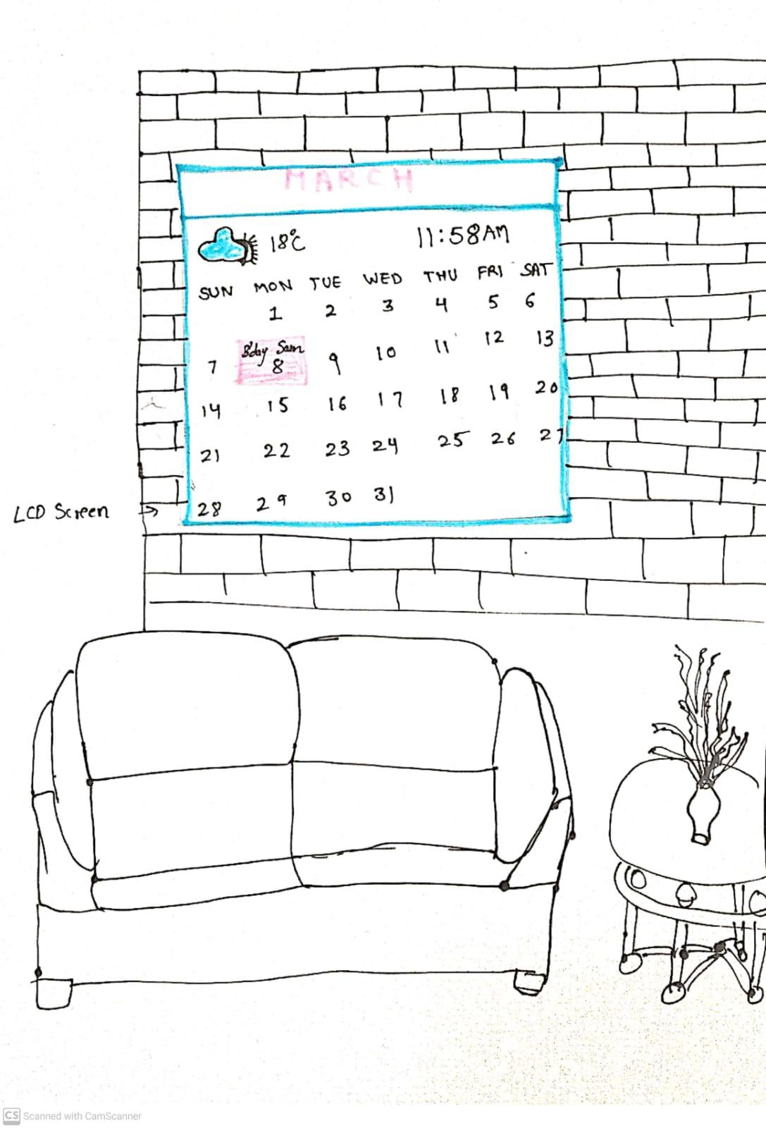

**Figure 1:Calendar in common area**

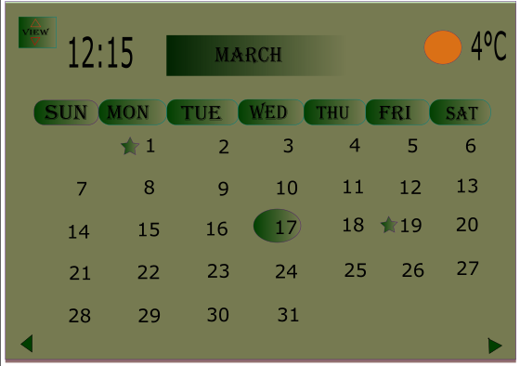

**Figure 2 : Calendar main display**



**Figure 3: Showing events when selected particular date**

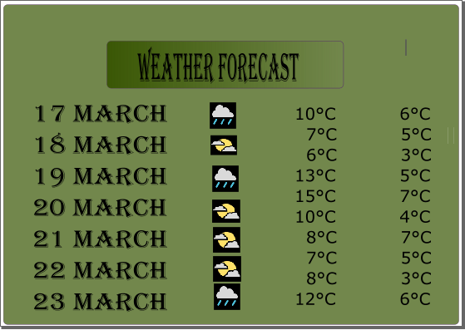

**Figure 4: Display of Weather forecast**

**3.Notice board:**

Smart Calendar Screen can act as very useful for displaying important information or notice to all the members in the house according to the different time slots and can be changed linking to the device.

**CONCEPT IN DETAIL**

The concept behind the smart screen calendar is displaying useful information like weather, time, date, and other important tasks to be done. This is the general information that we need not only in the morning but all through the day. To be productive and efficient, it becomes crucial to make most of the time available during the day. This project provides a clear example of how technology can be useful in making our daily life simple and easy.

The idea about the smart screen calendar is derived from the IOT concept with an effort to make everything around smart. The basic goal is providing people with smart technology making their daily routine simple and easy. Connecting Alexa using IOT enables the communication between user and a device.

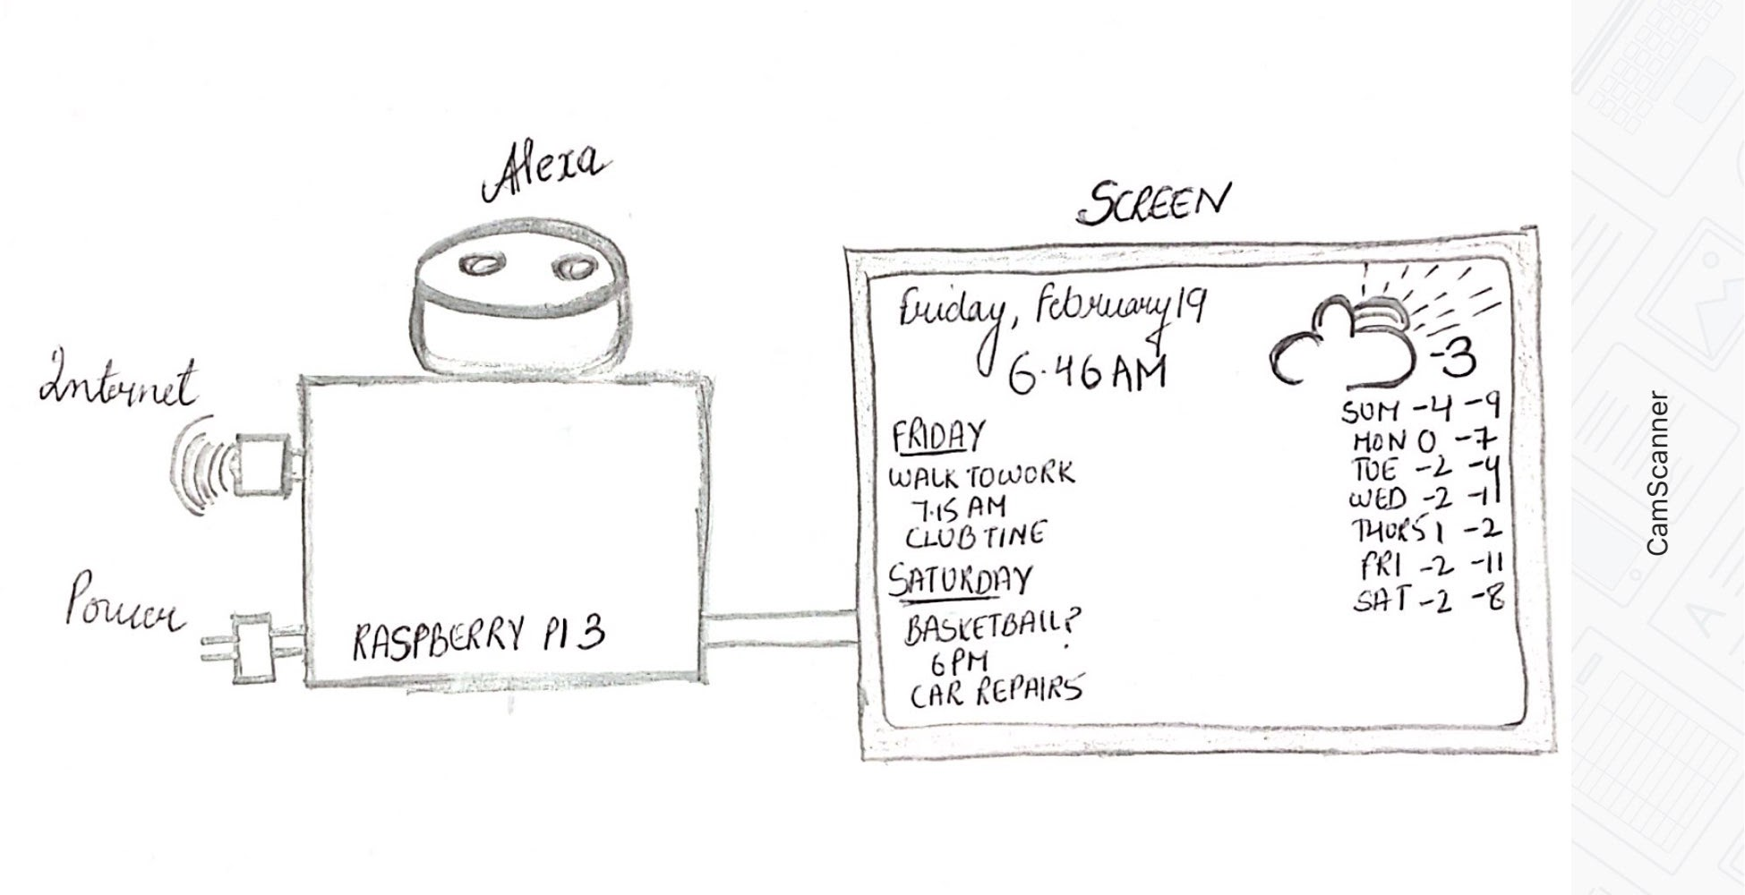

**Figure 5:Connection between Raspberry Pi and Screen**

Smart Calendar is a screen programmed with raspberry pi and is attached to a server to retrieve various kinds of data. Alexa, LCD Screen, HDMI cable are some additional components used to make this screen smart gadget. This Calendar is synchronized with the email so that changes can be made on important dates from anywhere from your phone or laptop.

**SYSTEM LEVEL ARCHITECTURE**

The architecture of the system is modular and works on the functioning of different modules which can be integrated together forming a single platform. All these modules put together the features like clock, current weather, news and other functionalities on a single single base.

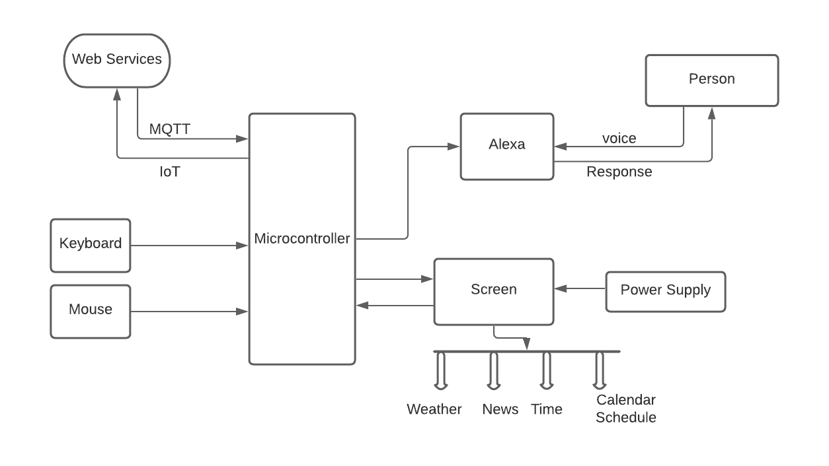

**Figure 6: Architecture**

**BLOCK DIAGRAM**

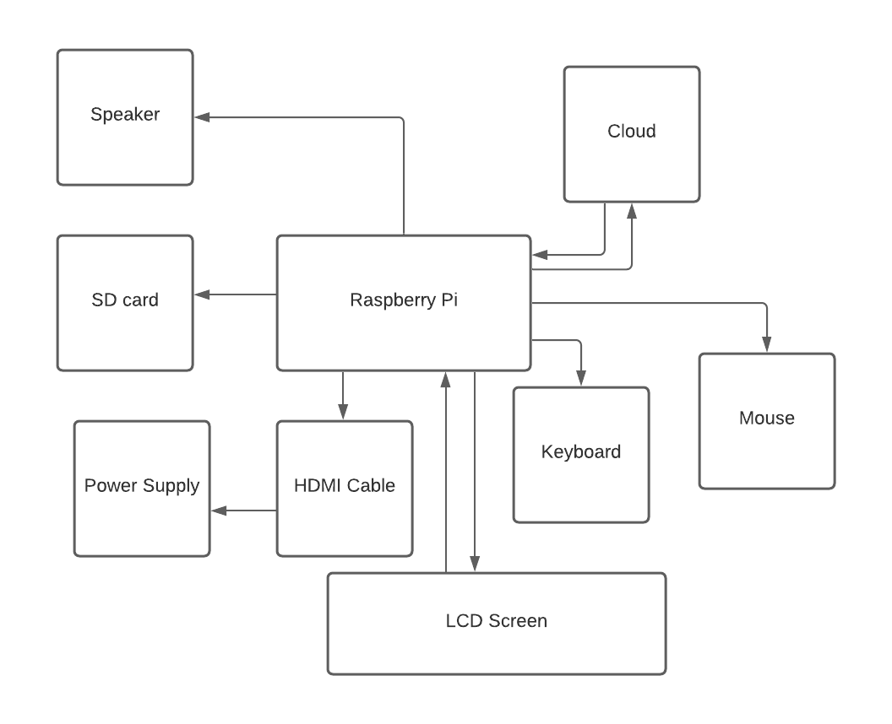

**Figure 7: Block Diagram**

**WORKING**

After getting all the components ready, the first step is to install the latest Raspbian operating system with the help of a microSD card using keyboard and mouse. Followed by installing Alexa for voice control operation of features like fixing any schedule by givinga command like “making an appointment” and it will respond according to the status. Raspberry Pi can be integrated with Alexa by making an Amazon Developer Account.There are few more steps to perform on Raspberry Pi like rotating the screen, disabling the screensaver, and getting the all up to date information. So that screen can show us all the required information by the user.All the features to be presented on the screen are described below under different modules -:

**Clock**

This module shows the date and time and is updated real time.The time is displayed in 24 hour format and ottawa time zone is used.

**Current Weather**

Module tells about the current weather along with sunset and sunrise time. The temperature is also shown with wind speed and icons with current condition. Weather information can be obtained online with current data.

**Alarm**

An array is created treating all alarms as objects which have properties like days, 24-hour format etc. A sound is set for a alarm and for undefined sound it is set with default alarm sound.Certain voice modules can also be accessed through voice commands like technology news, status, reboot and shutdown etc

**Weather Forecast**

This module displays the weather forecast for the week along with an icon displaying the current weather condition, minimum and maximum temperature.The url is the same as that of the current weather.

**Weekly Schedule**

It displays the present day timetable following a weekly recurring schedule. It is intended to maintain a weekly schedule with low update frequency and thus maintained manually.

**Slide changer**

This is a kind of extension to the all above modules, displaying all the modules in rotating carousel instead of displaying them all together.

**HARDWARE REQUIREMENTS**

**1] RASPBERRY PI 3 (Microcontroller)**

Raspberry Pi 3 Model B is with 64bit, 1.2 GHz quad core ARM cortex A53 Processor along with various on-board features like 2.4GHz WiFi, Bluetooth 4.1 classic and USB booting etc. storage is done using a microSD card .RAM of 1GB LPDDR2 (900 MHz) is present there .It consists of 40 pins header , populated. Raspberry pi is not a prototypical machine, it can be a simple card sized electronic board which can be found in electronics objects like our laptops, Pc etc.

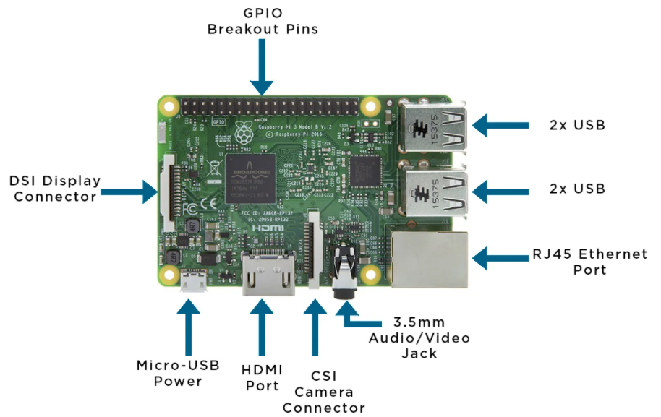

**Figure 8:Raspberry Pi**

To start working with the first step would be installing an operating system because PI will not work with any other OS.

Take 16 GB microSD for Raspberry Pi operating system.

* Select and download operating system software from <https://www.raspberrypi.org/downloads/>
* After installation of OS SD card is installed in PI board.
* Then the keyboard, mouse and screen are connected.
* Power is supplied to the board using the USB connector.
* Turning on the power board will run the installed operating system in the card and start from boot.
* When all the drivers are installed PI will ask for authorization which is set by default and can be changed
* After this will reach the screen where we can start the development of the application.

**2] SD CARD**

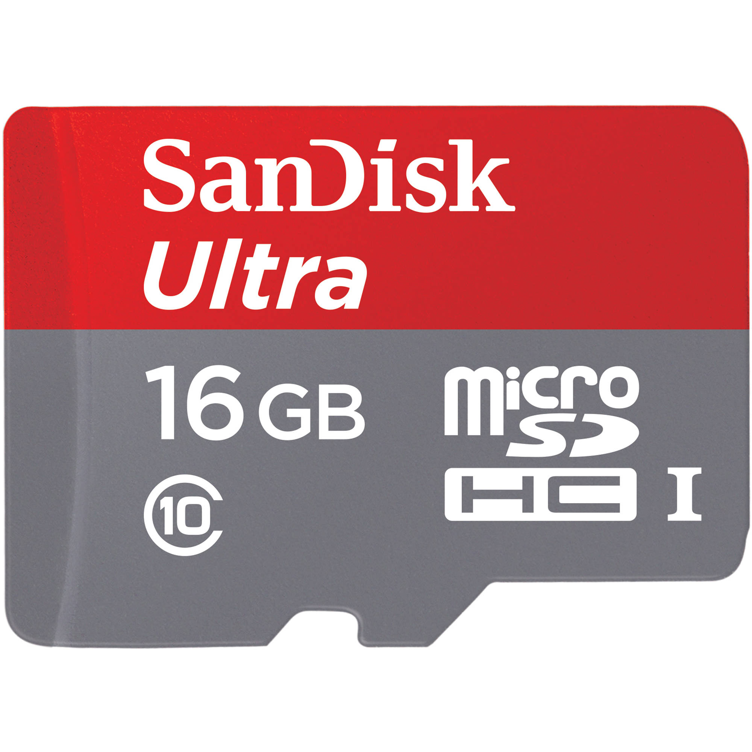

**Figure 9: 16GB MicroSD**

SD card (Secure Digital) is a kind of proprietary non-volatile memory card launched by SD association for use in various portable devices. It was released in 1999 and has dimensions as standard, Mini, Micro and follows the same mechanism as read. Its block size is variable with standard speed12.5 Mb/s to express greater than 985Mb/s.

**3] LCD SCREEN**

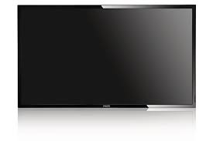

**Figure 10: 32 Inch Screen**

LCD a liquid crystal display is a flat electronic modulated optical screen device. Lcds display images same as general purpose computer displays or any fixed images such as words, digits as in seven segment displays. Lcd uses the same technology; only the images are made from a matrix of pixels. In our project our digital calendar will be displayed on a 32inch Lcd screen.

**4] KEYBOARD**

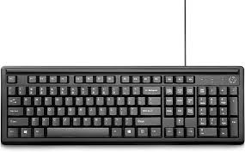

**Figure 11: Keyboard**

Keyboard is a kind of input device used with computers composed of buttons for letters, numbers and various symbols with unique features. Most keyboards connect computers using Bluetooth, USB or wireless communication. The use of a keyboard for our project is to give command to our microcontroller.

**5] MOUSE**

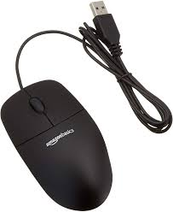

**Figure 12: Mouse**

Mouse is a hardware input device similar to a keyboard controlling a cursor in a graphical user interface (GUI) helps in moving and selecting icons, text, files and folders from screen. It helps in selecting and executing any function along with drag and drop, scroll and hover.

**6] USB-C**

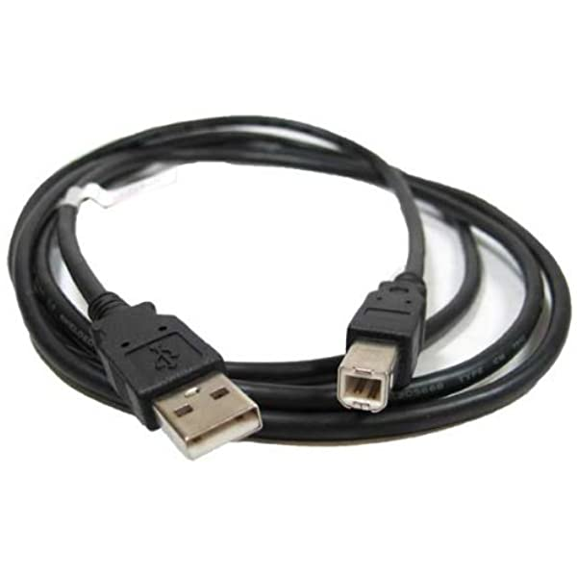

**Figure 13: Type C cable**

USB-C type cable is used for providing power supply to the raspberry-pi .

**8] ALEXA**

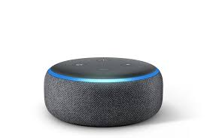

**Figure 14: Alexa**

Speaker is a hardware output device providing vocal commands to the software program. Here it could be used for music, sound, setting up alarms, providing weather updates, and providing real-time updates such as news.

**7] HDMI-Micro CABLE**

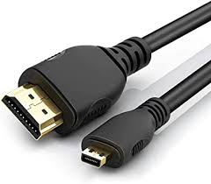

**Figure 15: HDMI Cable**

HDMI: High definition Multimedia interface . A Micro HDMI cable is type D connector and commonly used for transferring both high quality audio and video over a normal cable.

**SOFTWARE REQUIREMENT**

**AWS**- Amazon Web Services like cloud watch enables to set alarms and helps performing automatic actions based on predefined thresholds like monitoring or stopping any instance. Cloud can also be used for serverless services like AWS Lambda, AWS cloud Formation etc.

Alexa is voice based AI -powered by amazon. The instructions from the users are sent to cloud -based service called Alexa Voice Service (AVS).The digital assistant creates the smart environment .one can give commands to echo devices and can get outcomes.

Raspberry pi can be connected to AWS by signing in the AWS account . open the web browser on raspberry pi OS and go to aws.amzon.com by adding credentials

Echo is the latest device designed to connect Alexa , a cloud based voice powered by AWS.

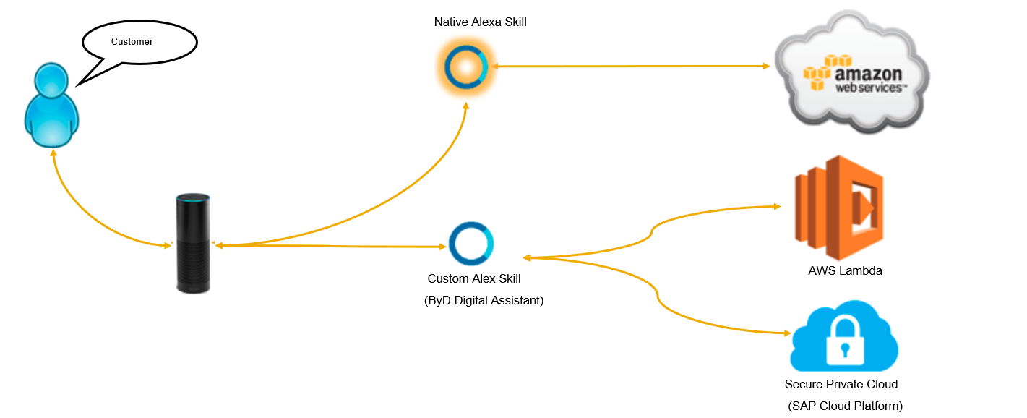

**Figure 16: Cloud**

**Operating System “Raspbian”** – Raspbian is a popular version of Debian which is a free operating system. It runs on a patched version of the Linux kernel . More than 35,000 packages which are precompiled software bundled in a format to install on raspberry pi .

Calendar can be customized depending on the requirement whether to use screen in landscape or portrait .With the help of configurations of the raspberry pi , screen can be rotated by typing the following command on the terminal .

sudo nano /boot/config.txt

**Figure 17: Installing raspberry pi OS**

Flash the latest Raspbian OS on MicroSD card from <http://downloads.raspberrypi.org/raspbian_latest>. Extract the image using Balena Etcher and once done open the terminal on the screen.

**FLOW CHART**

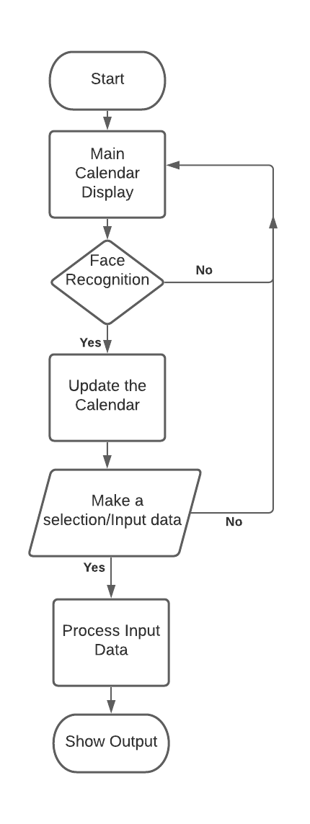

**Figure 18 : Flowchart**

The above flow chart shows the working of the Smart Calendar. Initially, the power is given to Raspberry Pi and the screen. When the screen is switched on, then the booting of Raspberry pi takes place. All the information about the date, weather and reminders will be displayed and updated timely when the user is in front of the calendar. Instructions are on the display based on user input different functions are called to display the required output.

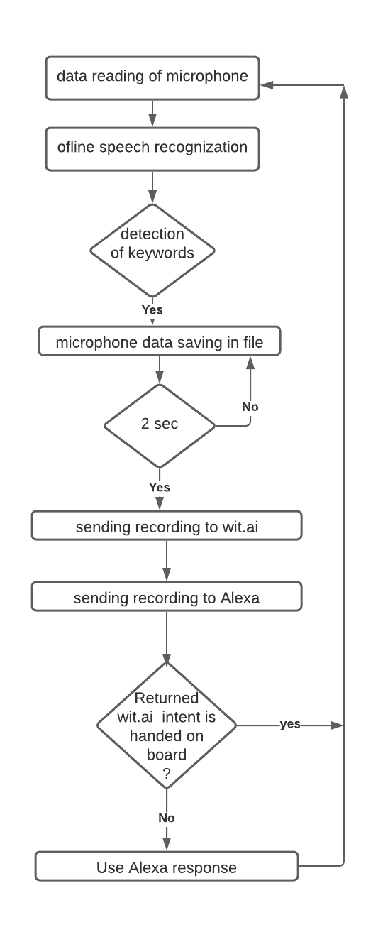

**Figure 19: Flow chart of Alexa**

**Wit.ai -** this is a special speech recognition serviceor can be machine learning . Reason for choosing this library is that it returns the “intents” that have been created with the user audio request.

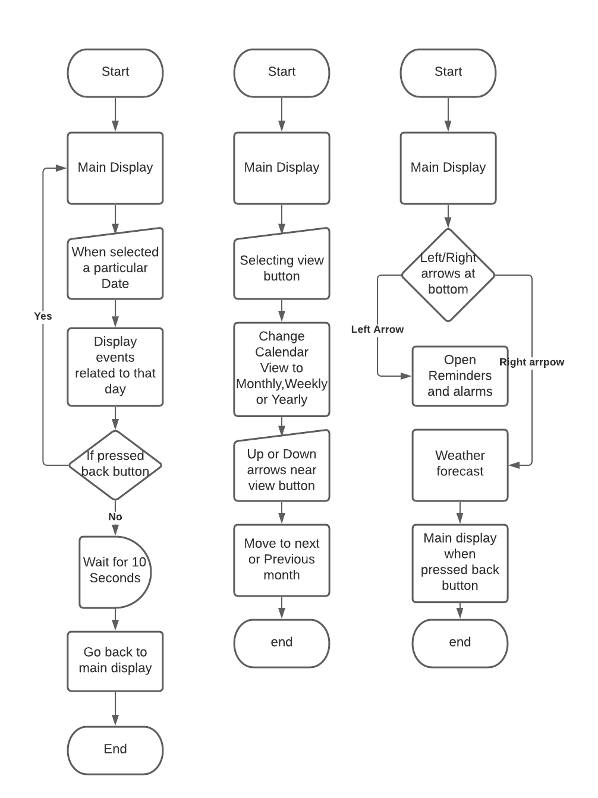

**Figure 20: Functions of Main display**

**QT WITH ALEXA**

* Voice assistants play an important role in everyday life . Qt is the best and strongest HMI platform available for embedded devices integration of voice services .
* QT based wrapper library that can abstract some of the low level functionality and then use it in an application . Amazon voice SDK and the architecture of that provides a lot of things as part of the SDK .
* Some things will happen locally on anyone's embedded device, the audio encoding and sending that up to the cloud where it is actually being parsed in the amazon voice service in the amazon voice service cloud instance and then you get back from amazon certain things depending on what you said .
* AVS (Alexa voice service ) enables developers to integrate alexa directly into products .
* Modular design and including a sample application.
* Alexa SDK and Amazon SDK provide a focus management library and with this library different technology can be implemented with ui feedback from the amazon interaction.
* Smart speaker functionality gives features of an echo, suppose echo is connected to amazon account it will send the desired thing which one asks/ orders.
* Smart speaker functionality when someone wants to play music connect to a spotify account connected to alexa account.
* Customizing the special features by using the system as voice assistant there is no actual C++ SDK functionality
* Go to Amazon website and develop the custom skills with alexa skills kit. This is a web based interface in which Keywords are entered
* Implement a client library to interface with the skill service.
* Alexa skill interface handles user actions and maps to events in the skill Service. the utterances of the semantics of speech will be mapped into intent events.
* To implement skill service, the web server, an HTTP server, JSON response mechanism, an SSL layer for security and signed certificate is required .
* Lambda function will change the value of an IOT device which could be any function which we set.

Amazon website and develop a custom skills with alexa skills kit thats web based interface that can actually have keywords

**GANTT CHART**

Gantt chart is used to describe the timings against their activities and is a visualization tool to depict activities in graphical form or bar chart. An individual can easily interpret it.

**Key points**

* **Dateline:** Vertical highlighted line describing
* **Bars:** Markers on the right side representing the start and finish of activities and durations
* **Milestones:** Major events, dates, deliverables
* **Progress:** How much work is done or completed.The horizontal blue line shows the work completed.
* **Resource assigned:** The team responsible for completing the task.
* **Tasklist:** vertical left side of Gantt chart to describe activities
* **Timeline:** Horizontal Across the top of Gantt chart

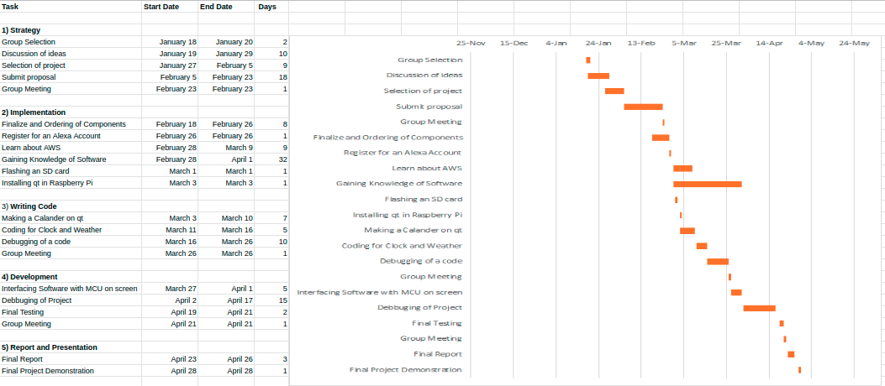

**Figure 21: Gantt chart**

**PROJECT COST ESTIMATION**

|  |  |  |  |
| --- | --- | --- | --- |
| **Component Name** | **Qty** | **Cost** | **Reference Link** |
| 1.LCD SCREEN | 1 | $120 | <https://www.amazon.ca/RCA-RT2412-24-Inch-720p-Renewed/dp/B086DZ6WG4/ref=sr_1_5?crid=2ABSKYID1WL5E&dchild=1&keywords=tv+22+inch&qid=1613521709&sprefix=tv+22%2Caps%2C167&sr=8-5> |
| 2.RA SPBERRY PI | 1 | $62.70 | [https://www.digikey.ca/en/products/detail/raspberry-pi/RASPBERRY%2520PI%25203%2520MODEL%2520B%2B/8571724?utm\_adgroup=Single%20Board%20Computers%20%28SBCs%29&utm\_source=google&utm\_medium=cpc&utm\_campaign=Shopping\_Product\_Embedded%20Computers&utm\_term=&productid=8571724&gclid=Cj0KCQiA962BBhCzARIsAIpWEL3L-RPh87Wg9DPJFY960bSGn05gIkX9Siuxrz6Jv-eW0It9c9\_9muAaAr7NEALw\_wcB](https://www.digikey.ca/en/products/detail/raspberry-pi/RASPBERRY%2520PI%25203%2520MODEL%2520B%2B/8571724?utm_adgroup=Single Board Computers (SBCs)&utm_source=google&utm_medium=cpc&utm_campaign=Shopping_Product_Embedded Computers&utm_term=&productid=8571724&gclid=Cj0KCQiA962BBhCzARIsAIpWEL3L-RPh87Wg9DPJFY960bSGn05gIkX9Siuxrz6Jv-eW0It9c9_9muAaAr7NEALw_wcB) |
| 3.HDMI CABLE | 1 | $15 | <https://www.amazon.ca/6-6feet-Lead-Snowkids-Compatible-Ethernet-Function/dp/B07K7HBZX2/ref=sr_1_1?crid=I5A5WW7IPBPV&dchild=1&keywords=hdmi+cable&qid=1613522314&sprefix=HDMI%2Caps%2C185&sr=8-1> |
| 4.SD CARD | 1 | $9 | <https://www.amazon.ca/Sandisk-Ultra-Micro-UHS-I-Adapter/dp/B073K14CVB/ref=sr_1_4?crid=ROBR3YBV4GW8&dchild=1&keywords=sd+card+16gb&qid=1613522434&s=electronics&sprefix=sd+card+16%2Caps%2C172&sr=1-4> |
| 5.KEYBOARD AND MOUSE | 1 | $15 |  |
| 6.ALEXA | 1 | $40 | <https://www.amazon.ca/Echo-Dot-3rd-gen-speaker/dp/B07WLVCCVK/ref=sr_1_3?dchild=1&keywords=alexa&qid=1613521539&sr=8-3> |
|  |  |  |  |

**Advantages of Calendar:**

* User Adaptive and adjustable.
* All languages can be used for the plugin.
* User friendly.
* Different user profiles can be operated.
* Useful for the busy person that wants to do multitasking and stay informed on the go.
* No need for additional devices like laptops or mobile phones to make changes or set reminders.
* Save paper or reduce paper waste.

**APPENDIX**

* **PIN CONFIGURATION OF RASPBERRY PI**

|  |  |  |
| --- | --- | --- |
| **PIN GROUP** | **PIN NAME** | **DESCRIPTION** |
| POWER | +5v, +3.3V, GND and Vin | +5V- Power output +3.3V- Power output, GND -Ground pin |
| COMMUNICATION INTERFACE | UART interface (RXD, TXD [GPIO 15, GPIO 14] | Universal Asynchronous Receiver transmitter used for interfacing sensor and devices |
| SPI INTERFACE (MOSI, MISO, CLK, CE) \*2  [SPI0-GPIO10, GPIO9, GPIO11, GPIO8]  [SPI1-GPIO20, GPIO19, GPIO21, GPIO7] | Serial Peripheral interface used for communicating with other peripherals |  |
| TWI INTERFACE (SDA, SCL]) \*2  [GPIO2, GPIO3]  [ID\_SD, ID | Two wireless Interface is used to connect peripherals |  |
| INPUT OUTPUT PINS | 26 | Multiple functionality can be considered as input /output pins |
| PWM | Hardware PWM available on pin GPIO12, GPIO13, GPIO18, GPIO19 | 4 channels PWM Outputs |
| EXTERNAL INTERRUPTS | All I/O | All I/O Pins can be used as interrupts |

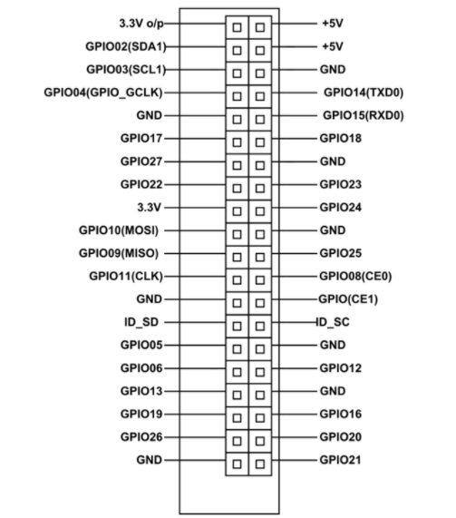

* **SPECIFICATIONS OF LCD SCREEN :**

|  |  |
| --- | --- |
| **DIMENSIONS** | **28.7 in x 8.6 in x 19.6 in** |
| **DISPLAY** | **LED-backlit LCD monitor /TFT** |
| **ASPECT RATIO** | **16:9** |
| **NATIVE RESOLUTION** | **1920 x 1080 at 60Hz** |
| **CONTRAST RATIO** | **1200:1 / 6000000:1 (dynamic)** |

**REFERENCES**

“Advanced Conversation Technology.” <https://www.actpower.com/educational/what-is-a-power-supply-and-how-does-it-work/>.

HANSELMAN, SCOTT. “How to build a wall mounted Family calendar and Dashboard with Raspberry pi.” 21 November 2018, <https://www.hanselman.com/blog/how-to-build-a-wall-mounted-family-calendar-and-dashboard-with-a-raspberry-pi-and-cheap-monitor>.

“Raspberry Pi 3.” 26 April 2018,

<https://smartbuilds.io/smart-mirror-touchscreen-raspberry-pi/>.

“Smart Mirror Touchscreen.” 9 May 2020, <https://smartbuilds.io/smart-mirror-touchscreen-raspberry-pi/>.

“Team Gantt.” *Gantt Charts*,

<https://www.teamgantt.com/what-is-a-gantt-chart>.

“what is the Raspberry Pi 3 ?” *ZD Net*, <https://www.zdnet.com/article/what-is-the-raspberry-pi-3-everything-you-need-to-know-about-the-tiny-low-cost-computer/>.